Education 261
Review for the chapters: 1, 2, 3, 5

Chapter 1

Ethics:
morals – values – loyalty – honest
Values leaders place in order to develop follows the loyalty, integrity, and honesty
*Discuss the model of ethics - Types of ethics: ethics of caring – justice – critique
Instructional leadership:
Types of leadership to help and develop instruction lead learning
Leading instruction and leading curriculum to promote students’ learning
The purpose: to develop – to promote students’ learning
Who are instructional leadership? Teachers, school principals, the minister of education, superintendents, supervisors, head of departments
PARENTS WRONG! “All of them right except PARENTS”
Public school are not instructional leader
Principals in “Kuwait” in “public” schools are instructional leaders (FALSE) (MANAGERS)
Knowledge base:
Building a hub or knowledge for information, it will be available for teachers, parents, community, and for the students to know what is required of the curriculum and what are the types of knowledge that they need to focus on
Leadership platform:
Special structure, special system, special domain for the leadership, for information knowledge, or data and for consultation
Organizational socialization:
It’s a process in which socialize all the activities and events
Ex: open day – events
Theory in use:
Reading and then apply it
((Action research))
Ex: New idea and then apply it “You tube”, using technology, using Kahoot
Human capital:
Involving and developing everything: values, skills, perceptions, experience
ISLLC standards:
Interstate school leaders licensure consortium
Teachers: They don’t have license
Leaders: They don’t have license
Leadership:
The ability to influence, to make a difference, to change, to inspire, and guide
Management:
Following the rules, guidelines, and policies from top management in our case ministry of education
All school principals are managers they only follow the guidelines and the process from the ministry of education, they don’t care, and they lack the ethics of care
MOE
Ministry of education
SLLA
School leadership license assessment

There are 3 types of people:
- Looker: depends on the look, they want to see the information
Tall, they care about the way that they look, wrinkles in their faces, thin lips, looking up or close their eyes so they are trying to remember the information
How do you interact “deal” with them?
Eye contact, catch their attention, using words to express, draw a plan, picture the plan
- Listener: 20% of the people
They don’t care about the way that they look (appearance not important to them), looking down and left while they are thinking, they put their hand on their head, pen clicker, avoiding eye contact, auditory words, talking to themselves
- Toucher: it represents 5% of the people around the world
Hug you but she never met you before, dressing casual clothes and comfort, reaching out to be closer
Deal? Set a limit, tapping on their shoulders, and touching with a distance

Chapter 2

The structure of ministry of education “What is the structure of education in public school”
Administration
Ministry of education
6 educational districts: Al-Ahmadi – Mubarak Al-Kabeer – Al-Jahra – Hawali – Farwaniya – Asimah the capital.
——————————————
Public schools in Kuwait they report their work “their job” to(the district)
They cannot contact the ministry directly
If you have a problem with you student, where do you go? Head of department
If the problem not solve? Vice principals – principals – district WHAT (DO WE CALL THIS?? Chain of command) DEF: Following “reporting” to your direct supervisor
- If you are teacher who is your supervisor (HOD)
- If you are school principals who is your supervisor (The district)
“If they have problem” Students at Gust: HOD – vice principals – Dean – the president
“If they have problem” Students at school: HOD – vice principals – the principal – the parents should contact the district
Which individuals or groups should you, as principal, meet on a regular basis?
Teachers, administrators, supervisors, parents
Politicians/strategic planners (Ministry of education)
True OR False: Citizens are concerned with “what is taught in the schools” (False)
They care about the grades; they don’t care about what they don’t teach in schools
Achievement gap: Measuring the differences in students achievements, schools, grades in the same grade level
EX: Let’s say student grades in English subject in this school the student fail, and in that school, students receive A’s, so here there is achievement gap why students are failing here and why students are getting A’s here, the same textbook were teaching, the same preparation for the teachers, the same building, the same budget, so they need to check the students in districts
Achievement gap job of who? HOD – supervisor – the school principal – district – MOE
Schools must focus on in order to understand the achievement gap and solve the problems:
- Achievement gap
- Clear curriculum choices
- Frequent assessments
- Changing the ways for evaluating the students learning
- Improving writing “nonfiction writing”
New technological demands: applications and how are you going to integrate technology
Are you with privatization or against? (Midterm question)
Definitions:
1.School choice: parents have the right where to send their kids private or public
2.Charter schools: more are specific on one type like religious
3.Magnet schools: To attract special type of students EX: gifted schools – school creativity – English schools – American schools – Indian schools

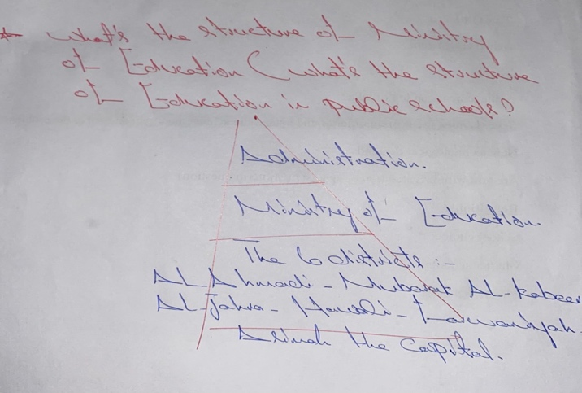

Chapter 3

Discuss the difference in roles between a leader, a manager, and an administrator?
- Leaders: they have the ability to make a change, to inspire, to influence, have mission, and vision (Long term plans), doing the right things so if they want to choose between two things, they will choose the right thing, they have strategic long-term plans and goals it could be 5-10 plan, they are doing action research
- Managers: controlling and following the rules and guidelines, care about their position and they care about doing things right, so they want to follow in a right way, they don’t care about which one is right, but they only do in a right way, they have short-term plans it could be daily, weekly, or yearly plans, they have the ability to implement the plans
- Administrators: they are responsible to make sure that everything is done in a right way that means they will take the credit if things are not done in the right way, then the people will blame them, they have plans
Important
1. Administration: responsible
2. Organizational responsibility: administration
3. Efficient to use sources: management
4. Organizational direction at purposes: leaders “vision, goals, purposes, direction”
5. Administrators are expected to be affected leaders (True), but the situation in Kuwait (false) not leaders
6. Leadership arranging from vision, mission, and inspiration (True)
7. Management is implementing the plans arranging resources, and seeing things get done (True)
8. Strong leaders are weak managers (false)
9. Strong managers are weak leaders (True)
10. Guiding improvement is the job of (leadership)
Greenfield work: he applied the scientific method, he questioned the scientific method
You cannot separate the environment, cannot separate your beliefs, your emotions, and circumstances around you, so his work was transformational leadership
Explain: the transformational leadership:
Transforming people values and beliefs to transform their idea about leadership
EX: the teachers prepare the students to be future teachers
Explain theory X and Y:
The founder is Douglas McGregor
There are two sets of beliefs “Two sets (types) of people (Leaders)” theory X and Y
X: They think that teachers are lazy and careless, I have to stand beside them to watch them (untrustful, follows bureaucracy)
❖ The ministry is applying theory X
Y: They are democratic, they trust teachers, they give them autonomy and they are only there to guide and to facilitate their work
IMPORTANTTTT: Based on the theory of X and Y evaluate the school principals’ role in Kuwait? what types of leaders in government school?
(X) They send HOD to go and check, also they are sending vice principals to check if they are late

7 habits of highly effective people:
1. Be proactive
2. Begin with the end in mind (vision)
3. Put first things first (put students first)
4. Think win-win
5. Seek first to understand then to be understood
6. Synergies
7. Sharpen the saw to the point
Explain the situational leadership:
Sometimes you are a manager but because the situation you become a leader, sometimes you are standing in front of them, sometimes you are just waiting behind, so that’s situational
- Based on the situation sometimes we see people becoming leaders
EX: One of the teachers become a leader by discussing (making discussion)
Distributed leadership:
Everyone has a role; you distribute the work then you are applying distributing leadership
EX: When you are a teacher and you want to put the students into groups one student will be note taker, one will be presenter, one will be data collector, one will be designing the slides
Dividing their work based on abilities and skills
Discuss the theory Z:
This is kind of leaders who applied the culture and characteristics, backgrounds, people’s personalities
The main goal of theory U:
(The U process)
Changing the approach (How)? You have to communicate and organize the plan, and change the way you perform
In order to change: you want to listen, observe, evaluate, communicate, plan, design

Questions for Chapter 5

- It’s your first year principal, and the superintendent has asked you to develop a work plan for your first year. What areas should you address in your work plan?
- Recent research in Education
- Meta-analysis by waters, Marzano, & McNulty 2003
- Leadership has a positive or negative impact on learning. How?
- Leithwood, Seashore Louis, Anderson, & Wahlstorm
- How powerful leaders turn around troubled schools?
- What structures and activities should you consider if you want to develop leadership opportunities for your teachers?
- What are the two goals of the self-directed learning (adult learning)?
- What is the goal of effective school leadership? How? P. 131 in textbook
- What is teacher leadership? What does it include? P. 133
- 3 roles teachers can play that will make a difference. What are they? P. 135
- Teachers collaboration. How?
- How will you support the change process as a principal?
- Recruitment, selection, induction, support, and evaluation P. 143-149
- Peer mentoring and coaching
- Performance appraisal and evaluation
- Staff development
- Employee Assistance program

GOOD LUCK!

